Introduction
Image processing is a method to convert an image into digital form and perform some operations on it, in order to get an enhanced image or to extract some useful information from it. A digital image is a representation of a two-dimensional image as a finite set of digital values, called picture elements or pixels. [1] Pixel values typically represent grey levels, colours, and distance from camera, etc. Pixel is the smallest element of an image. Each pixel corresponds to any one value. In an 8-bit grey scale image, the value of the pixel between 0 and 255. The value of a pixel at any point corresponds to the intensity of the light photons striking at that point. Each pixel stores a value proportional to the light intensity at that particular location. Enhancing edges of an image to make it appear sharper; an example is shown in figure. Note how second image appears “cleaner”; it is a more pleasant image. Sharpening edges is vital component of printing: in order an image to appear “at its best” on the printed page; some sharpening is performed.
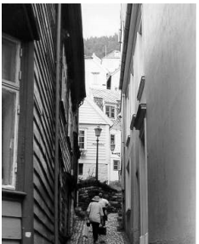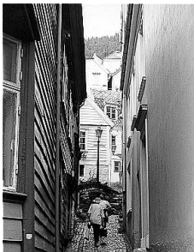
a) The original image b) Result after “sharpening”
we can also do different types of task using filters:
- Removing motion blur from an image
- Removing “noise” from an image
- Removing detail from an image.

Background
Image noise is random (not present in the object imaged) variation of brightness or colour information in images, and is usually an aspect of electronic noise. It can be produced by the sensor and circuitry of a scanner or digital camera. Image noise can also originate in film grain and in the unavoidable hot noise of an ideal photon detector. Image noise is an undesirable by-product of image capture that adds spurious and extraneous information.

- TYPES OF NOISE:
- Gaussian noise
B. Salt-and-pepper noise
C. Shot noise
D. Quantization noise (uniform noise)

- TYPES OF FILTERS:
A) Mean filter:
Mean filter is also known as Box filter and average filter. A mean filter has the following properties.2) It must be odd ordered 3) All the elements should be same.
B) Weighted average filter:
Properties of the weighted average filter are. 1)It must be odd ordered 2) The sum of all the elements should be. 3) The weight of centre element should be more then all of the other elements. 4) The two properties are satisfied which are (1 and 3). 5)But the property 2 is not satisfied. So in order to satisfy that we will simple divide the whole filter by 10, or multiply it with 1/10.
C) Gaussian Filter:
A linear smoothing spatial filter, whose coefficients are determined by gaussian function It assigns more weight to the position near the centre, and less weight to the positions far away from the centre
D) Median Filter:
Median filtering is a nonlinear operation often used in image processing to reduce "salt and pepper" noise. A median filter is more effective than convolution when the goal is to simultaneously reduce noise and preserve edges.
Design
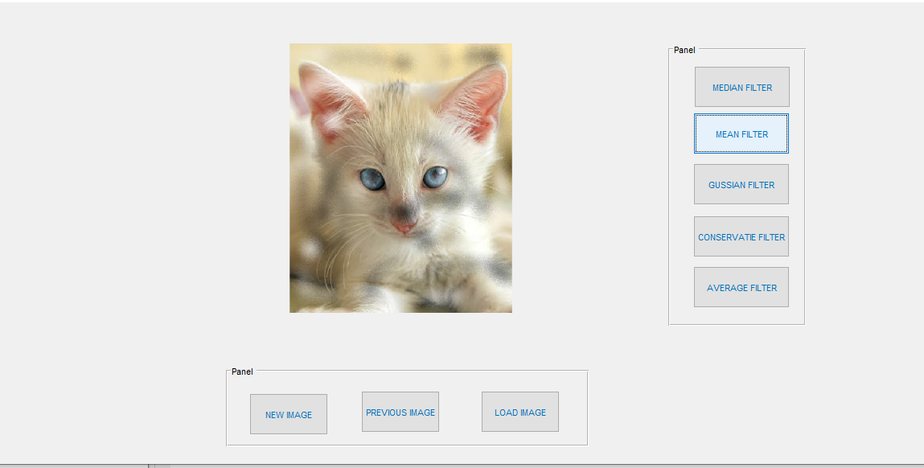
Implementation
- In filtering, modify the pixels in an image based on some functions of a local neighbourhood of pixels.
- B=infilter (A, h), A=original image, h=multi-dimensional filter, B=result
- In smoothing process simply average all of the pixels in a neighbourhood around a circle value
- Especially useful in removing noise from image but may lead to edge blurring
- Also useful for highlight’s gross detail

- The conservative smoothing filter (adaptive):

- In steps Firstly, the image is read by code.
- Then it converts the image into double value.
- After that it create a filter and matrix using ‘fones’
- Then it applies filter create new image which is ‘Img1’
- Then it plot the images get the output.
- The median smoothing filter:
- In steps Firstly, the image is read by code.
- Then we create median filter using ‘im_med’
- After that it create a filter and matrix using ‘fones’
- Then it applies filter create new image which is ‘median image’
- Then it gets output using ‘imshow’

- The mean smoothing filter:
- Mean filter replaces the intensity values of that pixels by the mean of the neighbourhood of that pixels.
- In the begging, the image read and then it gets size of image
- It set the neighbourhood boundaries there
- Then neighbourhood matrix gets denoted by some variable
- After that it pixels of the output will be the average value of neighbourhood.

- Graphical User Interface design:
- Open GUI file using the command ‘guide’
- Then create blank GUI.
- Guide layout editor using axis button drag one axis in editor.
- Then using panel create two panels in that drag and drop different buttons.
- One side is named as filters which has different types of filter and bottom side using as a new image, previous image, load images.
- Using different codes we design GUI according our Desire.

Results & discussion
- The conservative smoothing filter (adaptive):
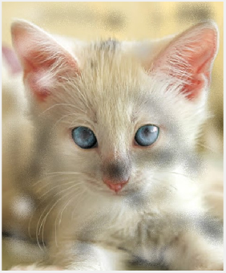

- The median smoothing filter:
Replace each pixel by the median in a neighbourhood around the pixel.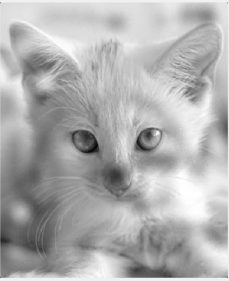

- Mean filter:
Mean filter is also known as Box filter and average filter
- It must be odd ordered
- The sum of all the elements should be 1
- All the elements should be same

4.Weighted average filter:
In weighted average filter, we gave more weight to the centre value. Due to which the contribution of centre becomes more than the rest of the values. Due to weighted average filtering, we can actually control the blurring.
- Properties of the weighted average filter are.
- It must be odd ordered
- The sum of all the elements should be 1
The weight of centre element should be more then all of the other elements
The two properties are satisfied which are (1 and 3).
But the property 2 is not satisfied. So, in order to satisfy that we will simple divide the whole filter by 10, or multiply it with 1/10.
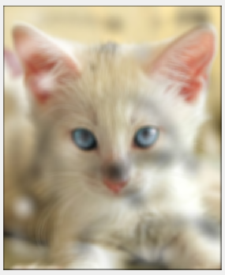

Conclusion
Filtering is perhaps the most fundamental operation of image processing and computer vision. In the broadest sense of the term "filtering".
the value of the filtered image at a given location is a function of the values of the input image in a small neighbourhood of the same location. Mean filter is the basic filter for blurring image. Gaussian blur is the fastest of the three options and is usually good for most applications. Median filtering is a non-parametric operation which is really useful when you want to get rid of things like speckle noise.
Neither Gaussian nor median filters preserve edges, meaning after applying the filter the location of edges in your image will move. A bilateral filter is edge preserving, but it is slower than a Gaussian filter.
REFEANCES
E.R DAVIES, 2018, Computer Vision, Fifth Edition, Academic press, United Kingdom, ISBN:978-0-12-803284-2
MATLAB codes:
1.The conservative smoothing filter (adaptive):
img=imread('Test_image.jpg');
imgd=im2double(img);%imgd in[0,1]
f=ones(3,3)/10;
img1=imfilter(imgd,f);

subplot(122);imshow(img1);
subplot(121);imshow(img);
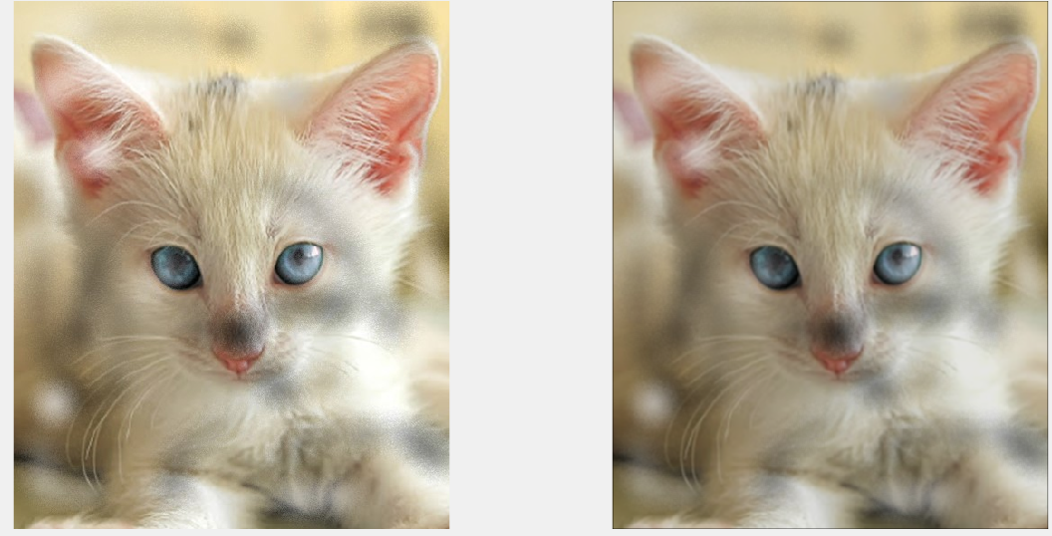
Fig1. conservative smoothing filter

2.The median smoothing filter:
img=imread('Test_image.jpg');
imgd=im2double(img);%imgd in[0,1]
img=rgb2gray(img);

im_med=medfilt2(img);
subplot(1,2,1),imshow(img),title('original Image');
subplot(1,2,2),imshow(im_med),title('median Image');
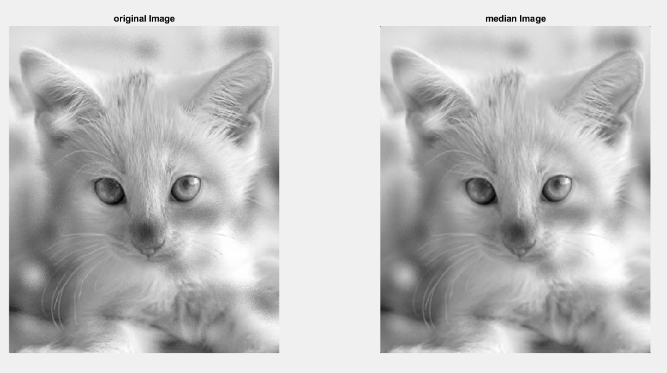
fig2.The median smoothing filter:

3.Mean filter:
clc
close all;
clear all;

I=imread('Test_image.jpg');
Img= rgb2gray(I);
[m,n] = size(Img);
output = zeros(m,n);
for i=1:m
for j=1:n
rmin= max(1,i-1);
rmax= min(m,i+1);
cmin= max(1,j-1);
cmax= min(n,j+1);
temp= Img(rmin:rmax,cmin:cmax);
output(i,j) = mean (:);
end
end
output= unit8(output);
figure(1);
set(gcf,'Position' ,get(0,'Screensize'));
subplot(121),imshow(img),title('orignal image');
subplot(122),imshow(output),title('mean filtered image');
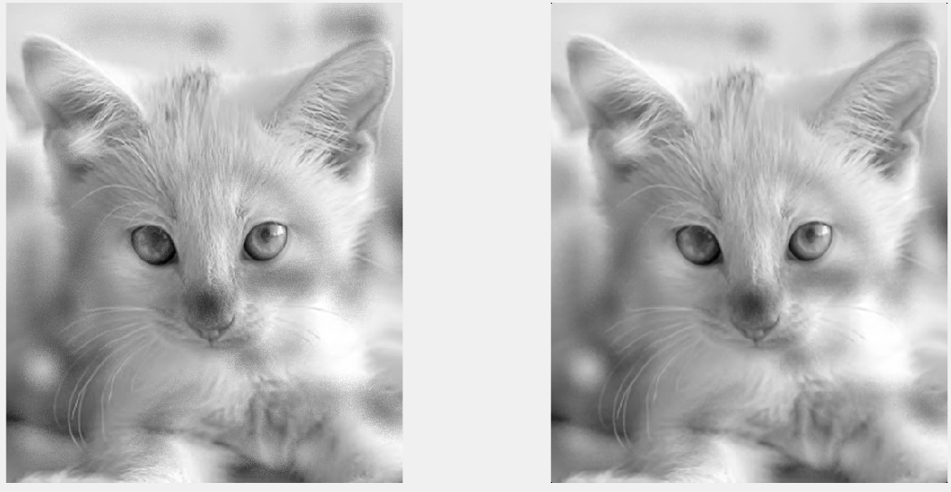
fig3.Mean filter:

4.Avearge filter

img=imread('Test_image.jpg');
imgd=im2double(img);%imgd in[0,1]
f_avg=fspecial('average',10);
im_avg=imfilter(img,f_avg);
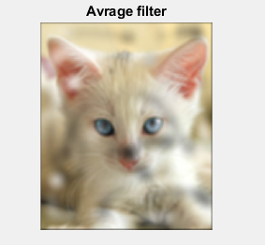
fig4.Avearge filter

5.Gassian filter:
img=imread('Test_image.jpg');
imgd=im2double(img);%imgd in[0,1]
f_gaus=fspecial('gaussian',10,0.7);
im_gaus= imfilter(img,f_gaus);
subplot(2,1,1),imshow(im_gaus),title('Gaussian filter');

subplot(2,1,1),imshow(im_avg),title('Avrage filter'); 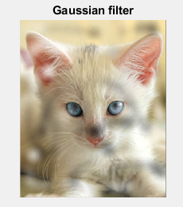
fig5.Gassian filter:

6.GUI DESIGN:

fig6.GUI DESIGN:

function varargout = DIPAK(varargin)
gui_Singleton = 1;
gui_State = struct('gui_Name', mfilename, ...
'gui_Singleton', gui_Singleton, ...
'gui_OpeningFcn', @DIPAK_OpeningFcn, ...
'gui_OutputFcn', @DIPAK_OutputFcn, ...
'gui_LayoutFcn', [] , ...
'gui_Callback', []);
if nargin && ischar(varargin{1})
gui_State.gui_Callback = str2func(varargin{1});
end

if nargout
[varargout{1:nargout}] = gui_mainfcn(gui_State, varargin{:});
else
gui_mainfcn(gui_State, varargin{:});
end
function DIPAK_OpeningFcn(hObject, eventdata, handles, varargin)

handles.output = hObject;

guidata(hObject, handles);

function varargout = DIPAK_OutputFcn(hObject, eventdata, handles)

varargout{1} = handles.output;

function pushbutton6_Callback(hObject, eventdata, handles)
global x;
[a,b]=uigetfile();
x=strcat(b, a);
x=imread(x);
axes(handles.axes1);
imshow(x);

function pushbutton7_Callback(hObject, eventdata, handles)
)

function pushbutton8_Callback(hObject, eventdata, handles)

function pushbutton1_Callback(hObject, eventdata, handles)
img=imread('Test_image.jpg');
imgd=im2double(img);%imgd in[0,1]
img=rgb2gray(img);

im_med=medfilt2(img);
title('median Image');

imshow(im_med)

function pushbutton2_Callback(hObject, eventdata, handles)
img=imread('Test_image.jpg');
imgd=im2double(img);%imgd in[0,1]
f=ones(3,3)/10;
img1=imfilter(imgd,f);
title('CONSERVATIVE FILTER');
imshow(img);

function pushbutton3_Callback(hObject, eventdata, handles)
img=imread('Test_image.jpg');
imgd=im2double(img);%imgd in[0,1]
img=rgb2gray(img);

im_med=medfilt2(img);
title('mean Image');

imshow(im_med)
function pushbutton4_Callback(hObject, eventdata, handles)
img=imread('Test_image.jpg');
imgd=im2double(img);%imgd in[0,1]
f_gaus=fspecial('gaussian',10,0.7);
im_gaus= imfilter(img,f_gaus);
title('gaussian filter');
imshow(img);

function pushbutton5_Callback(~, eventdata, handles)
img=imread('Test_image.jpg');
imgd=im2double(img);%imgd in[0,1]
f_avg=fspecial('average',10);

im_avg=imfilter(img,f_avg);
title('Avrage filter');
imshow(im_avg);

